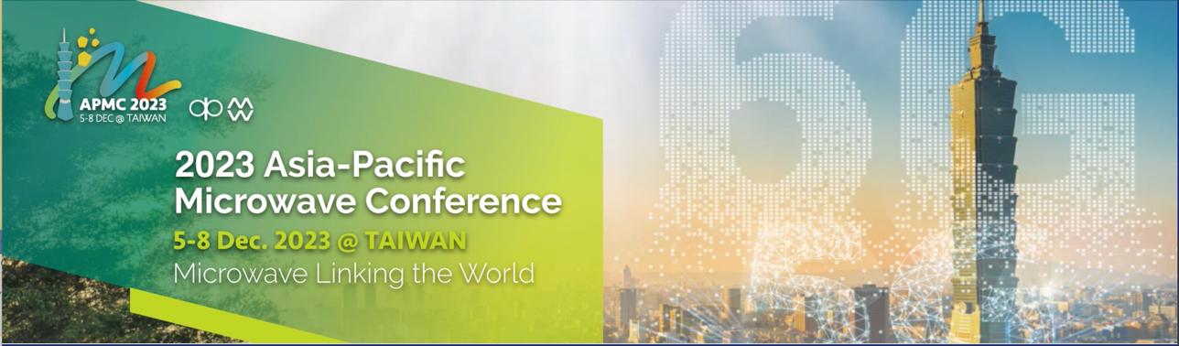
Call for Proposals – Special Sessions
(Deadline: June 10, 2023)

The APMC 2023 organizing committee cordially invites proposals for special sessions (http://www.apmc2023.org). Special session organizers are required to complete the table below with the proposed topic and scope, and email the form to: workshop.apmc2023@gmail.com by June 10, 2023.
Please list down the suggested speakers and/or the tentative titles of their papers if known at this time. Here are some notes for your attention:

- All proposals will be evaluated by the committee considering various factors.
- A special session is expected to have 5 papers. If more papers are accepted for a special session, it will be split into part A and part B.
- The authors may choose to submit one-page format for not including their papers in IEEE Xplore and full-length (3 pages) submission is mandatory for considering IEEE publication. All papers will be reviewed as regular submissions by external reviewers.
- Organizers/speakers are encouraged to invite speakers from diversified regions/countries.
- Organizers/speakers are required to register for the conference with corresponding registration fees.
- We would like to seek your understanding that the special sessions may be cancelled or combined with other sessions of similar topics should there be insufficient number of speakers.

Organizers’ information (please provide Name, Affiliation, Email)
Title of Session
Abstract of Session (less than 200 words)
List of speakers and/or titles of their papers (if known)
Presentation Guidelines:
- The time limit for each presentation is 20 minutes and this includes;
- 15 minutes for the presentation itself, and
II. 5 minutes for Q&A
- You are requested to register at least 15 minutes prior to the commencement of the section. Please bring your presentation saved on a USB memory stick and load your presentation on the computer.
- A projector and a computer with Windows OS, MS PowerPoint installed will be available in the venue.

