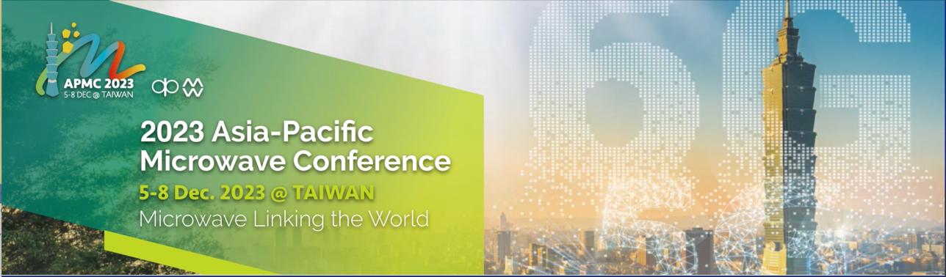
Call for Proposals –APMC2023 Workshop Preliminary Proposal
(Deadline: June 10, 2023)

The APMC 2023 organizing committee cordially invites proposals for workshop in this conference (http://www.apmc2023.org/). The workshop is scheduled to be held on December 5, 2023. The workshop organizers are suggested to complete the template below with the proposal including a subject title and its scope. Please email the form to workshop co-chairs: workshop.apmc2023@gmail.com by June 10, 2023. In the proposal, please advise the speech subject and/or the names of the speakers (if available). Below is some key information for your attention:
1. All workshop proposals will be evaluated by the conference committee in consideration of various criteria and factors.
2. All the workshops shall be arranged on December 5, 2023. The duration of each workshop is suggested to half-day (A full-day session may be reviewed for the arrangement of meeting hall).
3. We would like to seek your kind understanding that the workshops may be canceled or combined should there be an insufficient number of participants or other unforeseen circumstances.

Workshop Title
Organizer name(s)
Organizer
contact information
Brief abstract
(Less than 250 words)
List of suggested speakers  and /or titles (if known) | 1.  2.  3.  4.  :  :

